Practical No. 4
Exam Seat No: 22510044
Name : Ritesh Ramchandra Patil
Batch : B8

Title of practical:
Study and Implementation of Synchronization

Problem Statement 1:

Fibonacci Computation:
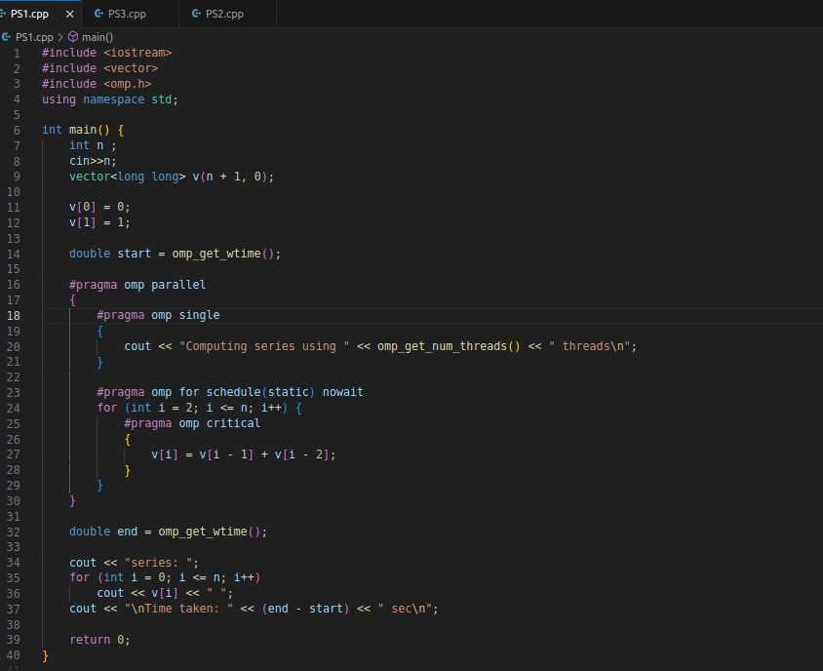

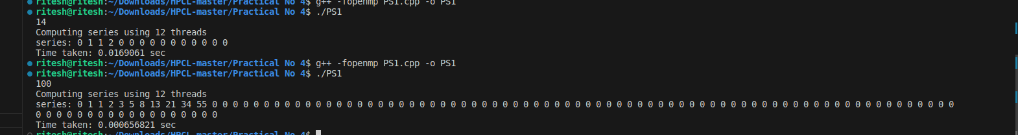

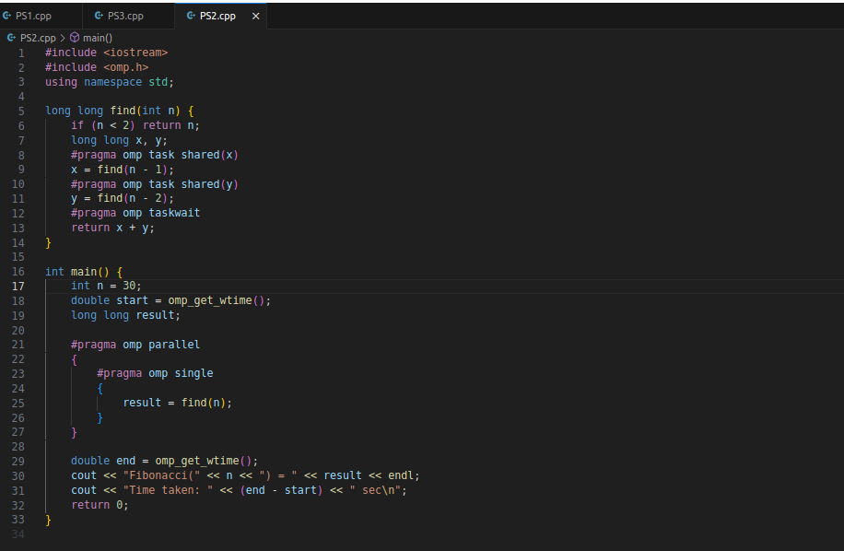

Information:

To implement Fibonacci number computation in parallel using OpenMP, considering synchronization requirements and demonstrating the use of different clauses and constructs.

Problem Description
The Fibonacci sequence is a series of numbers in which each number is the sum of the two preceding ones. It starts with 0 and 1, and the formula is:
F(0)=0,F(1)=1,F(n)=F(n−1)+F(n−2)for n≥2
Example sequence:
0, 1, 1, 2, 3, 5, 8, 13, 21, …

Parallelization Goal
The task is to speed up Fibonacci computation by using multiple threads.
- In the recursive approach, independent recursive calls can be executed as parallel tasks.
- In the iterative approach, computations are sequentially dependent but can still be parallelized in some stages or restructured.

Why Synchronization is Needed
In iterative computation, each Fibonacci number depends on the two preceding numbers.
If multiple threads update or read shared variables without synchronization:
- Data races may occur.
- Results can be inconsistent or incorrect.
OpenMP provides constructs like critical, single, taskwait, and flush to ensure data consistency.

Problem Statement 2:

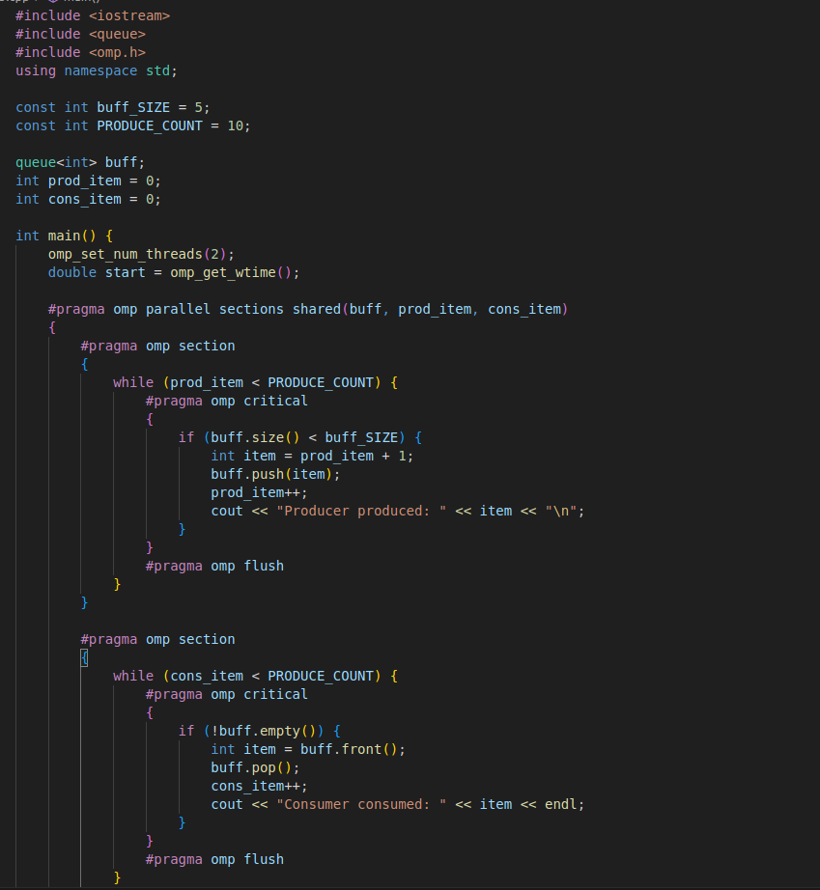
Producer Consumer Problem

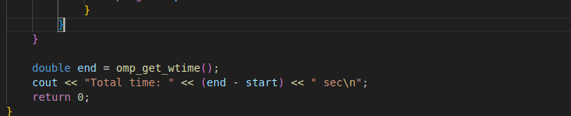
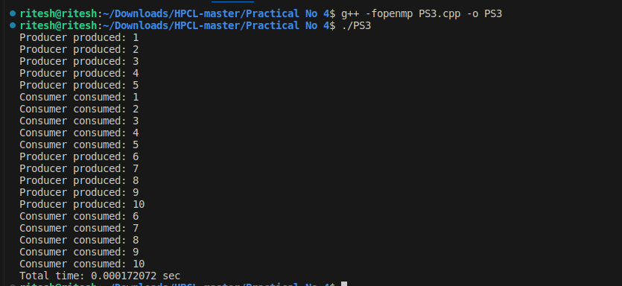

Information:

The Producer–Consumer problem is a classic synchronization example in concurrent programming where:

- Producer generates data items and places them into a shared buffer.
- Consumer removes data from the buffer and processes them.
- Synchronization is required to prevent:
  - Buffer overflow
  - Buffer underflow
  - Data races

Parallelization with OpenMP :
OpenMP allows us to create multi-threaded producer–consumer code using:
- parallel sections — to assign separate threads for producing and consuming.
- Synchronization constructs — to coordinate access to the shared buffer.

Github Link: https://github.com/ritesh6569/HPCL

